Name : Hadiya Naeem
Roll no: SU92- BSAIM-F25-078
Section: BSAI-3B
Lab task 3
Introduction:
In this lab we study about serach algroithms like DFS , BFS, UCS, IDDSF, DLS ect. We implemented these algorithm in python and draw there graph.
Problem statement and state space formulation
The path find strating node a to goal node in a grapy
initial state : A
goal state: G
actions: move fron one connected node to another
path: the total cost of traveling along the select edge
breadth first search and Depth first search
breadth first search explore the graph level by level. It uses first in first out algroithm
depth first search explore one branch deeply before returing to another branch. It uses last in first out.
BFS Result
Visites order: A,B,C,D,E,F,G
final path A B E G
DFS Result:
Visited order : A,B,D,E,G
Final path : A B E G
Program :
from collections import deque

graph = {
"A":["B","C"],
"B":["D","E"],
"C":["F"],
"D":[],
"E":["G"],
"F":[],
"G":[]
}

def bsf (start , goal):
queue = deque ([(start,[start])])
seen ={start}
order =[]

while queue:
node, path = queue.popleft()
order.append (node)
if node == goal:
return path , order

for n in graph [node]:
if n not in seen:
seen.add(n)
queue.append((n,path + [n]))

def dfs(start, goal):
stack = [(start, [start])]
seen = set ()
order = []
while stack:
node, path = stack.pop()

if node in seen:
continue
seen.add(node)
order.append(node)

if node == goal:
return path, order
for n in reversed(graph[node]):
stack.append((n, path + [n]))
bfs_path, bfs_order = bsf("A", "G")
dfs_path, dfs_order = dfs("A", "G")

print("BFS visit order" ,bfs_order)
print("BFS path", bfs_order)

print("BFS visit order", bfs_order)
print("BFS path", bfs_order)

output:
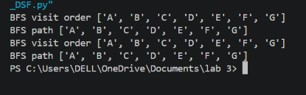

Depth limited serach (DLS) and iterative deepening (IDDFS)
DLS is type of DFS that searches only up to a given depth limit
IDDFS runs DFS repeatedly incressing depth limit
FOUND: the goal found
CUTOFF: the depth limits stops
FAILURE: no solution is found in the explored
Depth limit | DLS status | path
1 | CUTOFF | Not found
2 | CUTOFF | Not found
3 | FOUND | A B E G
4 | FOUND | A B E G

Program :
graph = {
"A":["B","C"],
"B":["D","E"],
"C":["F"],
"D":[],
"E":["G"],
"F":[],
"G":[]
}

def dls(node, goal, limit, path):
if node == goal:
return "FOUND", path

if limit == 0:
if graph [node]:
return "CUTOFF", None
return "FAILURE",None
cutoff_found = False

for child in graph[node]:
if child not in path:
status, result = dls (
child, goal, limit - 1, path + [child])

if status == "FOUND":
return status, result

if status == "CUTOFF":
cutoff_found = True
if cutoff_found:
return "CUTOFF", None
return "FAILURE", None

def iddfs (start, goal, max_depth):
for limit in range (max_depth + 1):
status, path = dls(start, goal, limit,[start])

print("limit:",limit,"status:", status)

if status == "FOUND":
print("path", path)
return path

iddfs("A","G",4)

output:
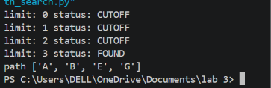
Uniformed Cost Search (UCS)
UCS is a search algorithm that selects the nodes with the lowest total path cost.
Edge | Weight
A B | 1
A C | 6
B D | 5
B E | 1
C F | 2
C G | 6
E G | 1

Program:
import heapq
graph={"A":[("B",1),("C", 6)],
"B":[("D", 5),("E", 1)],
"C":[("F", 2), ("g", 6)],
"D":[],
"E":[("G", 1)],
"F":[],
"G":[]
}

def ucs (start, goal):
pq = [(0, start, [start])]
best ={start: 0}
order = []

while pq:
cost, node, path = heapq.heappop(pq)
if cost != best [node]:
continue
order.append(node)
print("processing", node, "cost", cost)

if node == goal:
return path, cost, order

for child, weight in graph[node]:
new_cost = cost + weight

if new_cost < best.get(child, float("inf")):
best[child] = new_cost
heapq.heappush(pq, (new_cost, child, path +[child]))

path, cost, order = ucs("A", "G")
print("ucs path",path)
print("total cost:", cost)
print ("processing order:", order)

output:
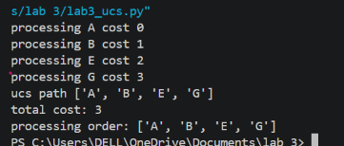

Edge case:
Observed : the search cannot find first goal
Likey cause: the goal is not reachable through the available
Reflection :
In this lab I learn how different search algroithm explore a graph.
The difference between in BFS and DLF with IDDLE and DLS

